

SCHOOL OF COMPUTER SCIENCE AND ENGINEERING

NAME:MOHITH.J | SUBMISSION DATE: 06 / 01 /2018
REG.NO: 17BCE2135 | SLOT: | L27+L28

1. TO VERIFY TRUTH TABLE OF AND, OR, BUFFER AND NOT GATES

1. A. AND GATE
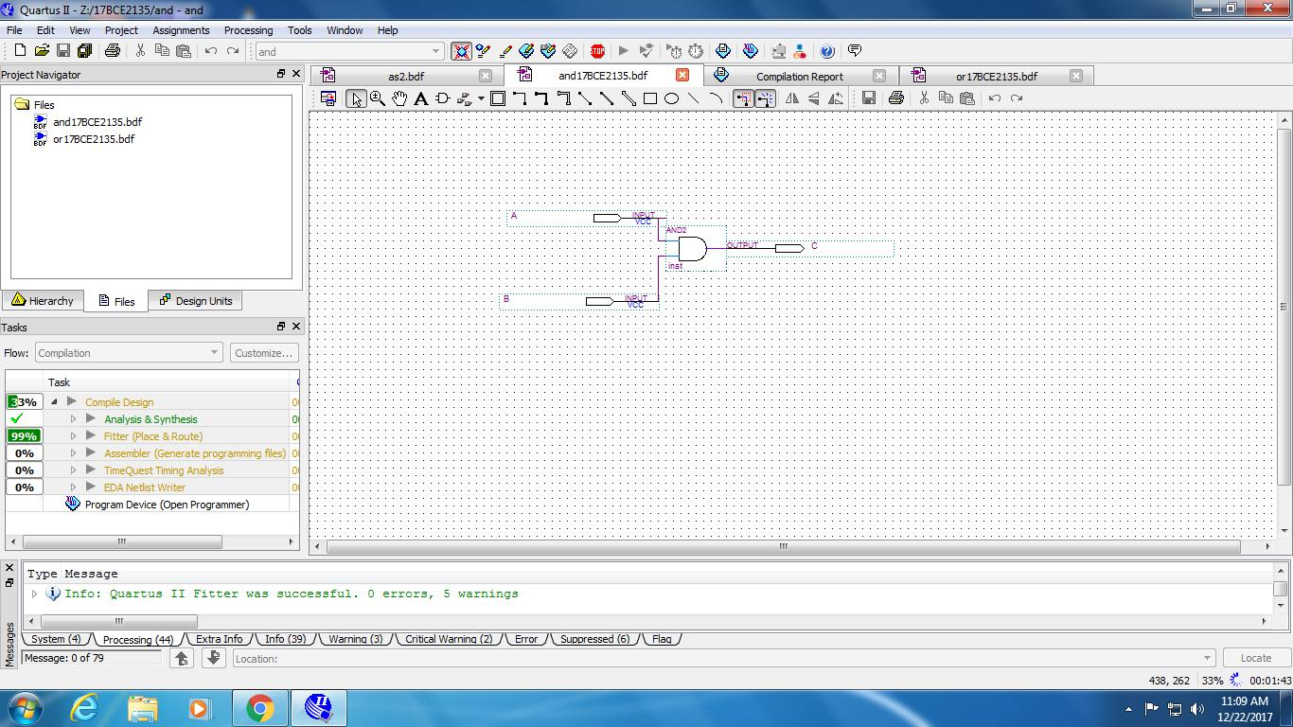

FIGURE 1: SIMULATION LOGIC AND GATE

1 | P a g e

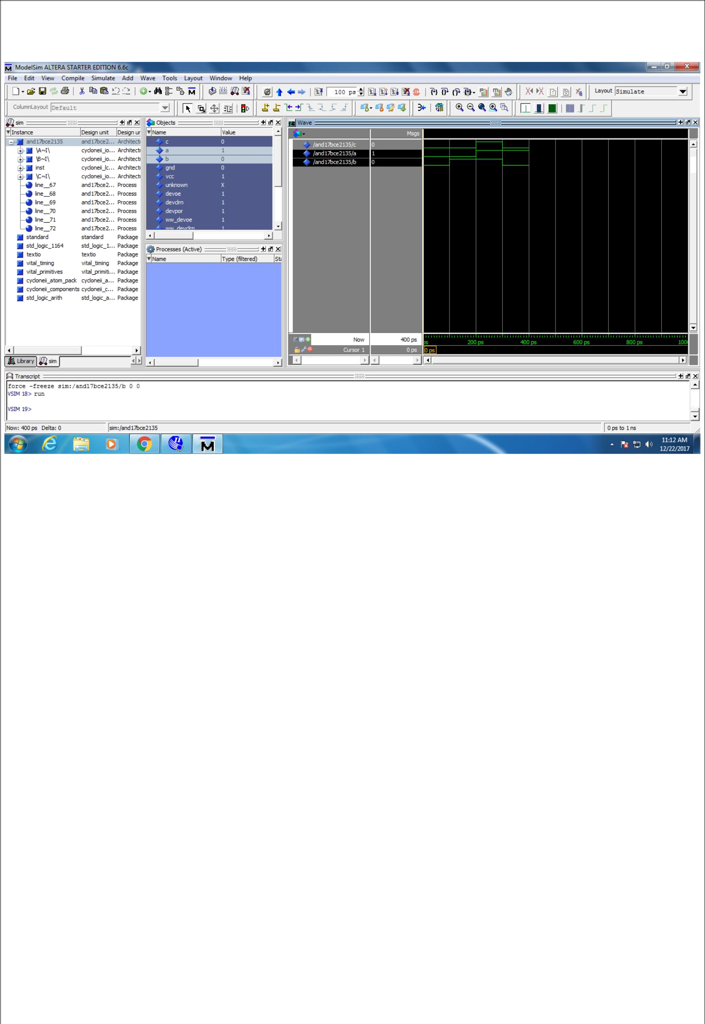

FIGURE 2: SIMULATION OUTPUT OF LOGIC AND GATE

A | B | C
0 | 0 | 0
0 | 1 | 0
1 | 0 | 0
1 | 1 | 1

TRUTH TABLE

2 | P a g e

1. B. OR GATE
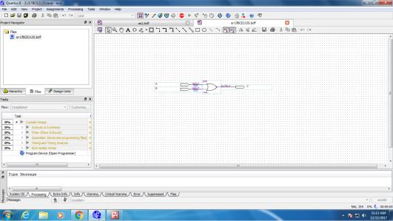

FIGURE 3: SIMULATION LOGIC OR GATE
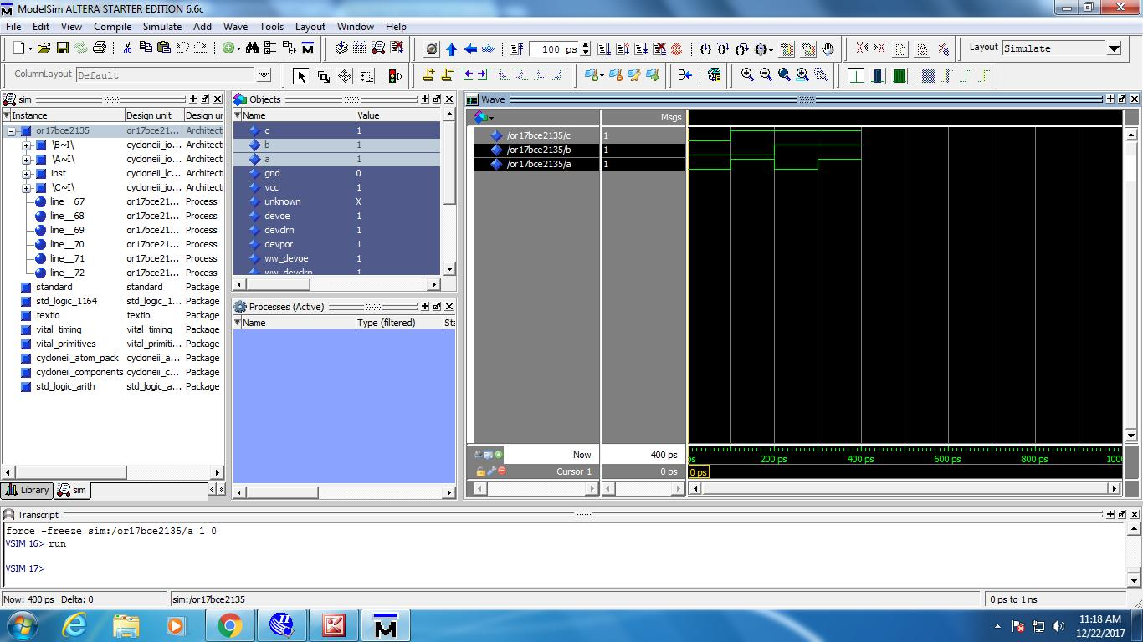

FIGURE 4: SIMULATION OUTPUT OF LOGIC OR GATE

3 | P a g e

A | B | C
0 | 0 | 0
0 | 1 | 1
1 | 0 | 1
1 | 1 | 1

TRUTH TABLE

1. C. BUFFER GATE
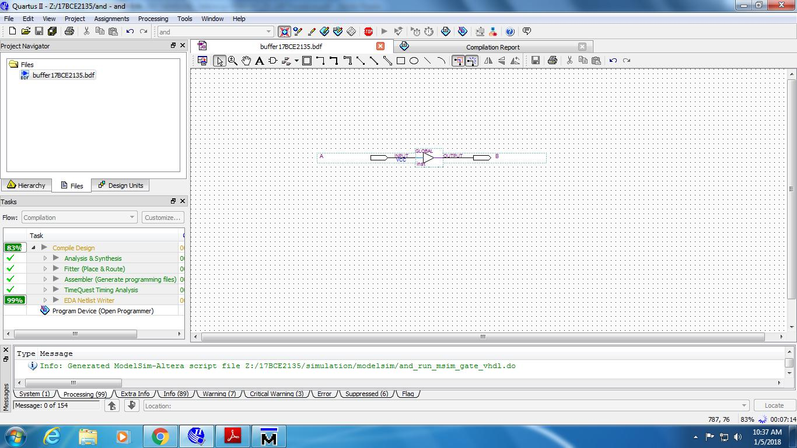

FIGURE 5: SIMULATION LOGIC BUFFER GATE

4 | P a g e

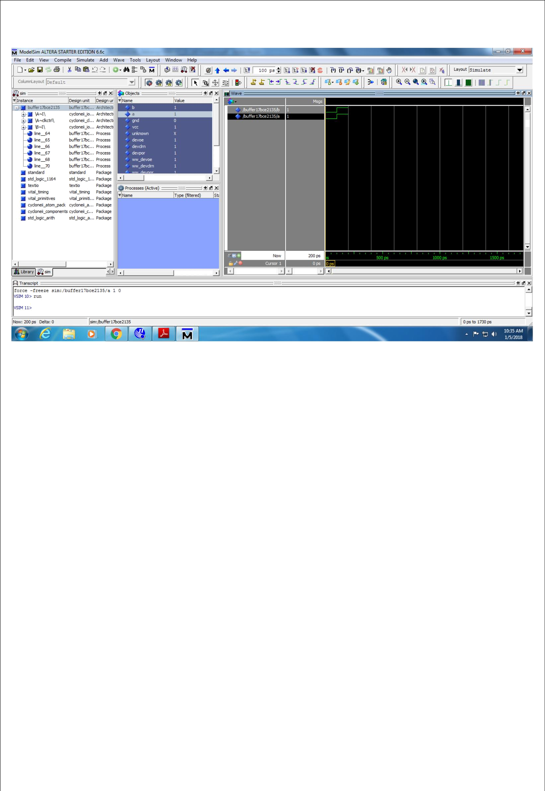

FIGURE 6: SIMULATION OUTPUT OF LOGIC BUFFER GATE

A B

- 0

11

TRUTH TABLE

5 | P a g e

1. D. NOT GATE
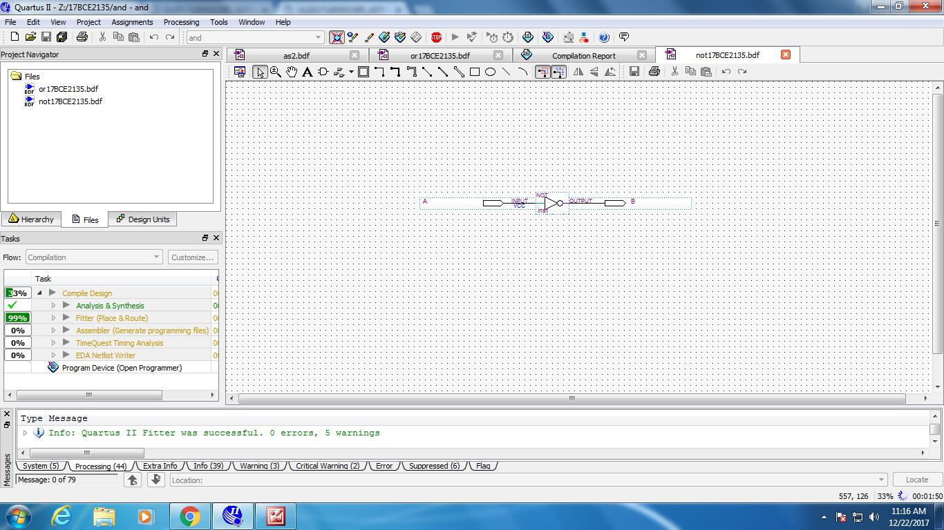

FIGURE 7: SIMULATION LOGIC NOT GATE
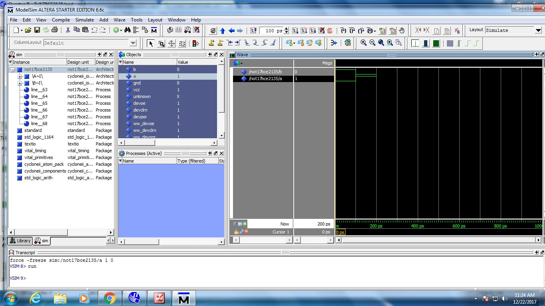

FIGURE 8: SIMULATION OUTPUT OF NOT GATE

6 | P a g e

A B

- 1

10

TRUTH TABLE

  - TO VERIFY TRUTH TABLE OF NAND AND NOR GATE

- A. LOGIC NAND GATE
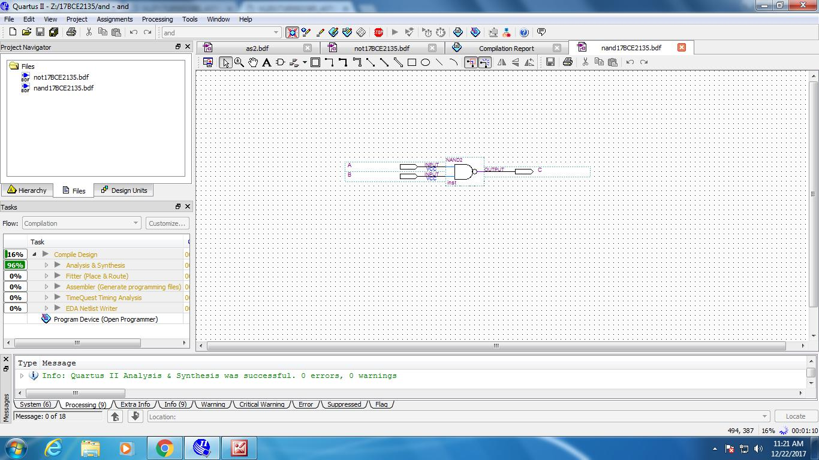

FIGURE 9: SIMULATION LOGIC NAND GATE

7 | P a g e

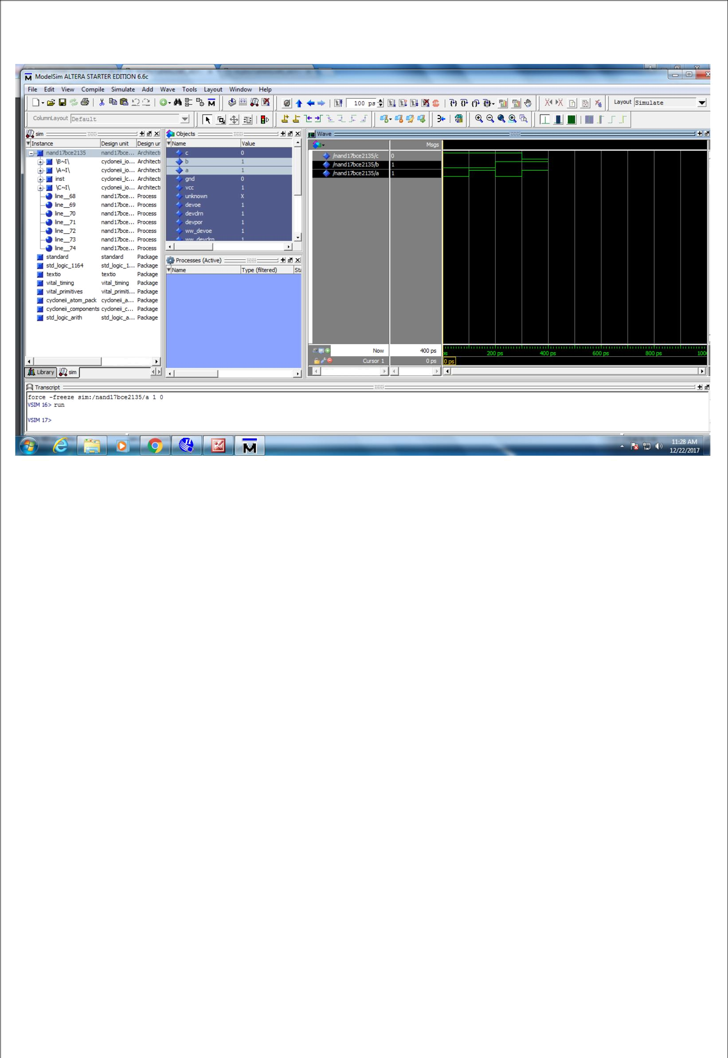

FIGURE 10: SIMULATION OUTPUT OF LOGIC NAND GATE

A |  | B |  | C
0 |  | 0 |  | 1
0 |  | 1 |  | 1
1 |  | 0 |  | 1
1 |  | 1 |  | 0
 | TRUTH TABLE

8 | P a g e

2. B. LOGIC NOR GATE
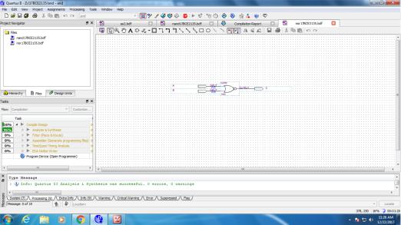

FIGURE 11: SIMULATION LOGIC NOR GATE
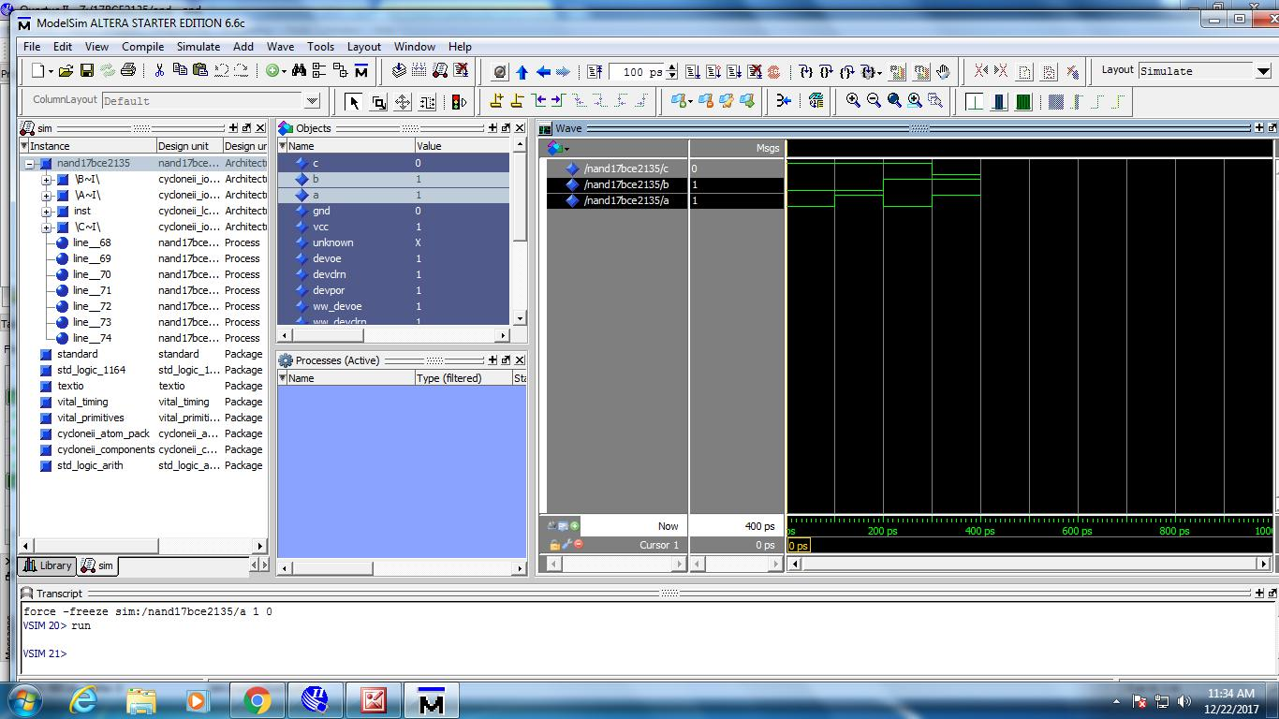

FIGURE 12 : SIMULATION OUTPUT LOGIC NOR GATE

9 | P a g e

A | B | C
0 | 0 | 1
0 | 1 | 0
1 | 0 | 0
1 | 1 | 0

TRUTH TABLE

3. TO VERIFY TRUTH TABLE OF XOR AND XNOR GATE

3. A. XOR GATE
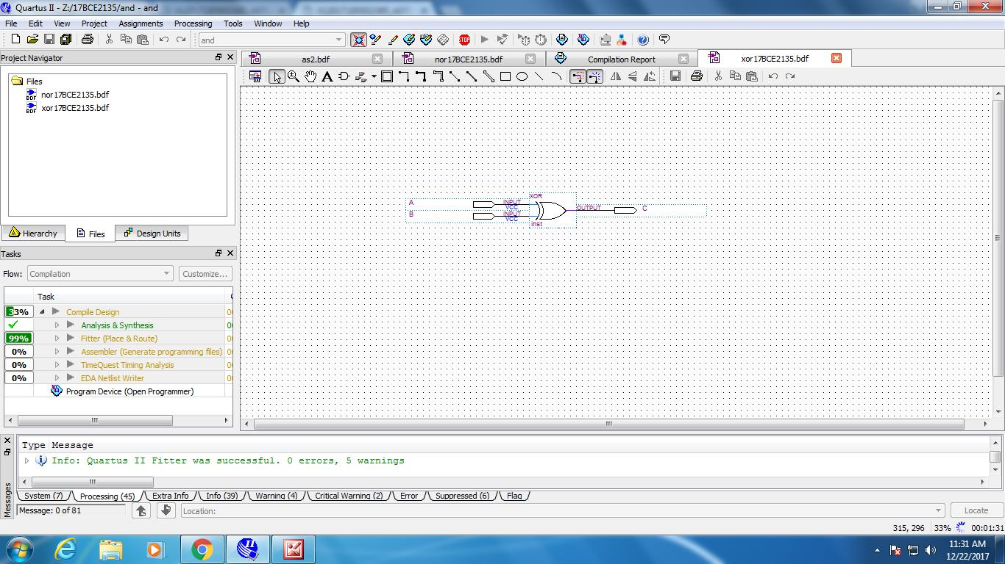

FIGURE 13: SIMULATION LOGIC XOR GATE

10 | P a g e

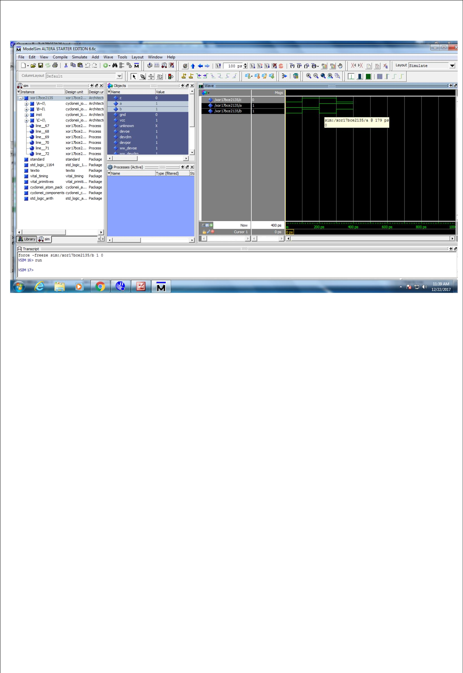

FIGURE 14: SIMULATION OUTPUT FOR LOGIC XOR GATE

A | B | C
0 | 0 | 0
0 | 1 | 1
1 | 0 | 1
1 | 1 | 0

11 | P a g e

3. B. XNOR GATE
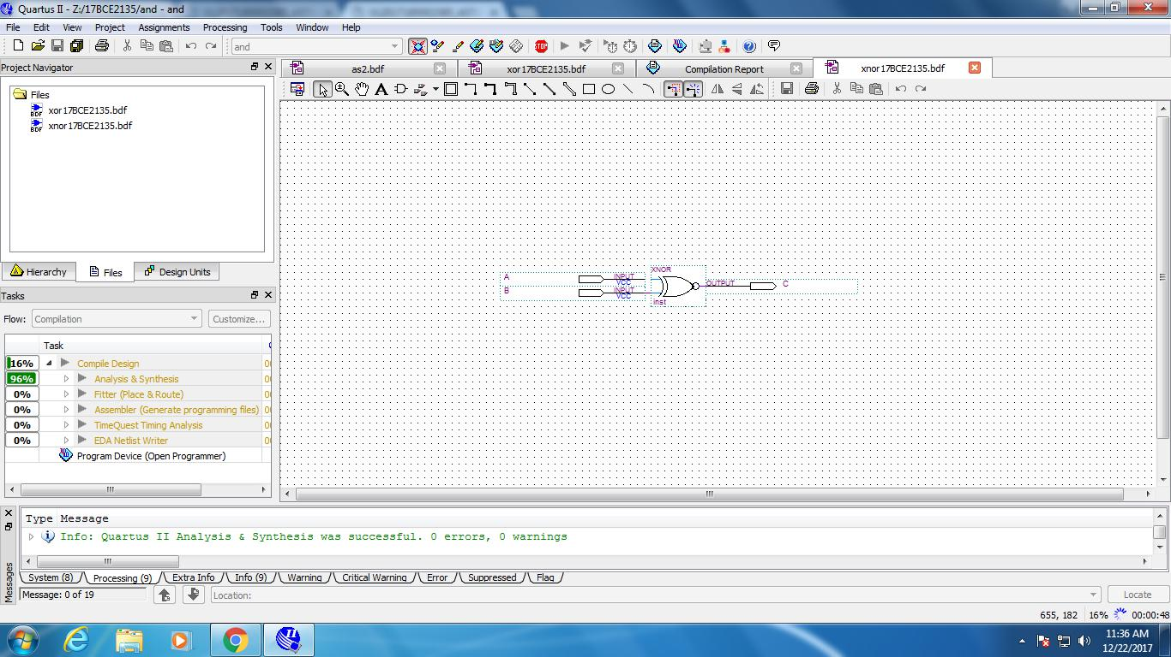

FIGURE 15: SIMULATION LOGIC XNOR GATE
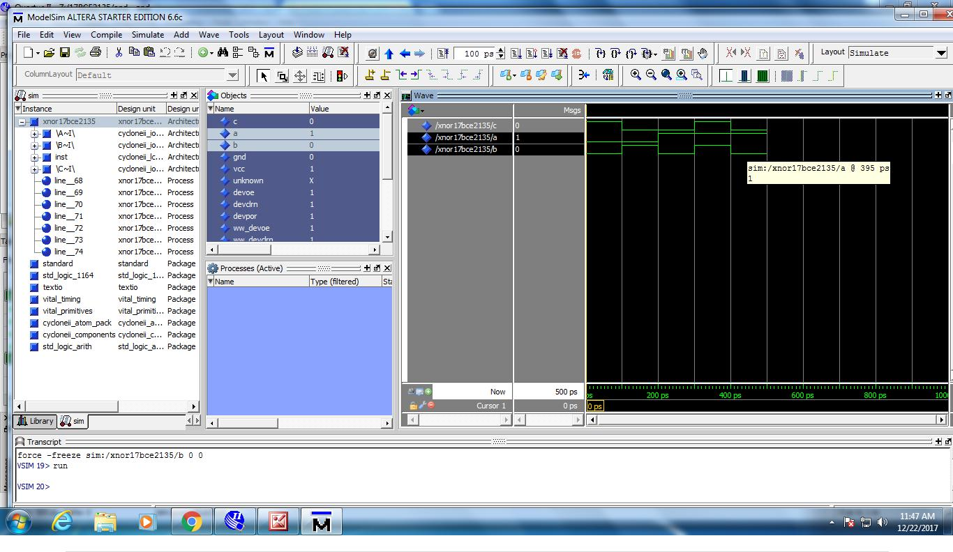

12 | P a g e

FIGURE 16: SIMULATION OUTPUT FOR LOGIC XNOR GATE

A | B | C
0 | 0 | 1
0 | 1 | 0
1 | 0 | 0
1 | 1 | 1

TRUTH TABLE

13 | P a g e

